
Koneru Lakshmaiah Education Foundation
(Deemed to be University estd. u/s. 3 of the UGC Act, 1956)
Off-Campus: Bachupally-Gandimaisamma Road, Bowrampet, Hyderabad, Telangana - 500 043. Phone No: 7815926816, www.klh.edu.in

STUDENT CASE STUDY EXECUTION REPORT
Department | FED
Subject | DSA-2
Academic Year | 1-111 Semester | 2025-26
Faculty Name | Mohd. Razia Alangir Banu
Student Name | P. Yaswanth Surya
Roll Number | 2520030581
Branch | CSE
Course Outcome | CO 1
Case Study Topic: Attendance Search System Using Searching Algorithms
Work Done Summary:
In this case study, we implemented an Attendance Search System for managing and retrieving student attendance records efficiently. The system allows users to search attendance details using a Student ID. Different searching techniques were applied and analyzed to compare their efficiency. We evaluated the performance of Linear Search and Binary Search methods on attendance datasets and observed their execution times.

Implementation Details:
1 Created a dataset containing student attendance records.
2 Implemented attendance search functionality using Student ID.
3 Applied Linear Search to locate attendance records.
4 Sorted attendance data and implemented Binary Search.
5 Measured the search time for both algorithms.
6 Compared the efficiency and performance of Linear Search and Binary Search methods. 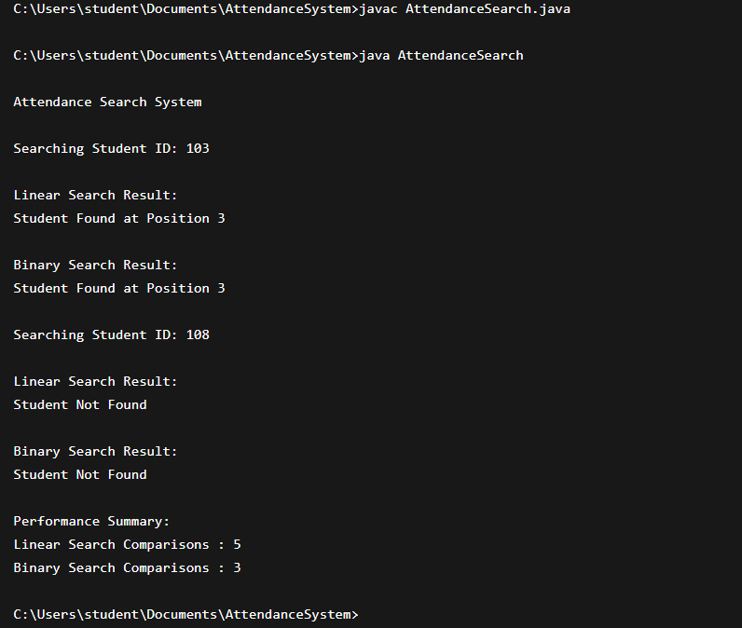

Result: Screenshots / Output
Result: Screenshots / Output
Student ID: 2520030595
Attendance Found:
- Name: S. S. Pradyumn
- Attendance Percentage: 92%
Search Performance Comparison:
- Linear Search Time: 0.0052 ms
- Binary Search Time: 0.0011 ms

Time Complexity:
Linear Search: O(n)
Binary Search: O(log n)

The Binary Search algorithm performed significantly faster than Linear Search for large attendance datasets. The Attendance Search System successfully retrieved attendance records and demonstrated the advantages of efficient searching techniques.

GitHub Link: https://github.com/yaswanthsurya-99/DSA-2
Student Signature Faculty Signature

